Lab 1

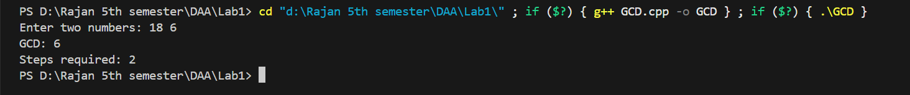**GCD Output:**

**Factorial Output:**

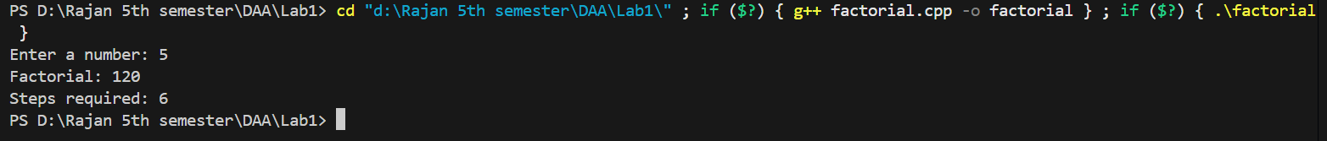

**Fibonacci Output:**



**Sequential Search Output:**

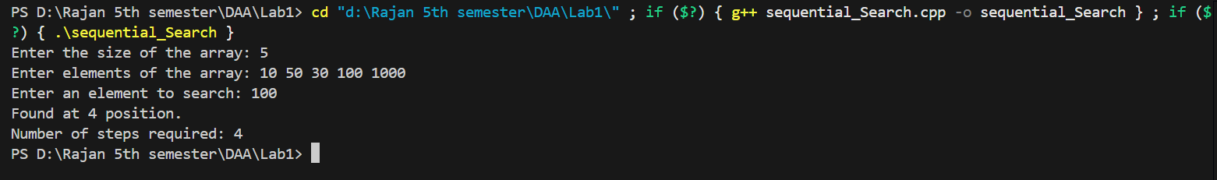

**Bubble Sort Output:**

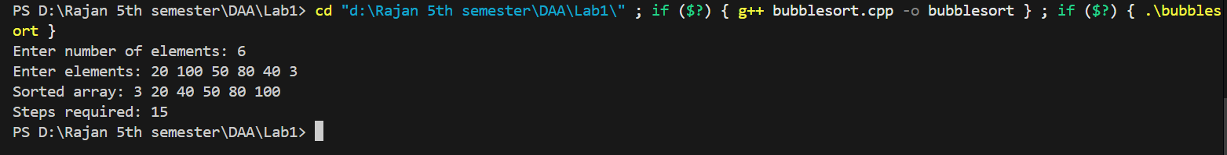

**Selection Sort Output:**

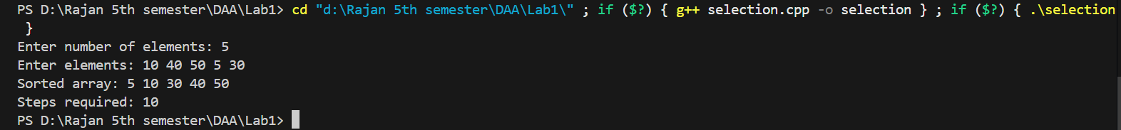

**Insertion Sort Output:**

